1917 Russian Revolution
The 1917 Russian Revolution was not a well organized event in which Czar (Tsar, Tzar) Nicholas II was overthrown and Vladimir Lenin and the Bolsheviks took power. It was a series of events that took place during 1917 which led to two separate revolutions in February and October. These revolutions eventually plunged the country into Civil War before leading to the founding of the Communist State.
The first major event of the Russian Revolution was the February Revolution, which took place after a century of civil and military unrest. The causes of the problems of the common people with the Czar and aristocratic landowners were numerous. The most important difficulties included the cruel treatment of peasants by wealthy people and the monarchy, poor working conditions experienced by city workers and a growing sense of political and social awareness of the lower class in general. Democratic ideas were reaching Russia from the West and political activists gained popularity. Dissatisfaction of the lower class was further compounded by food shortages and military failures. In 1905, Russia experienced humiliating losses in the Russo-Japanese War. During a demonstration against the war in the same year, Czarist troops fired upon an unarmed crowd - further dividing Nicholas II from his people. Widespread strikes, riots and the famous mutiny on the Battleship Potemkin ensued.
The political climate in 1905 was so dangerous that Tsar Nicholas saw fit, against his will, to give in to the people their wishes. In his October Manifesto, Nicholas created Russia's first constitution and established an elected parliament. However Nicholas's belief in his divine right to rule Russia meant that he spent much of the following years fighting to undermine or strip the new parliament of its powers and to retain as much control as possible.
When Archduke Franz Ferdinand was assassinated by political activists in Serbia in 1914, the Austro-Hungarian Empire declared war on its neighbors. Serbia turned to Russia for help. Tsar Nicholas II saw a chance to unite his people against a common enemy, and to atone for the humiliations suffered in the Russo-Japanese war. Things did not work out as he had planned.

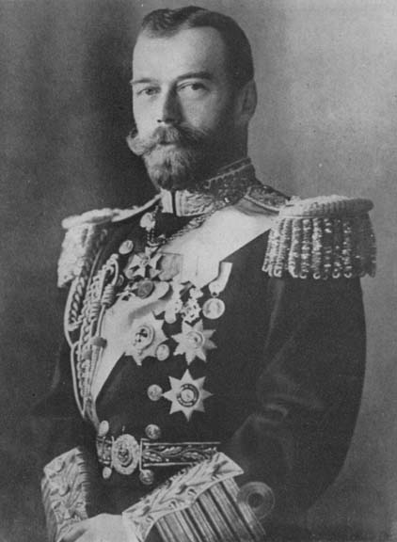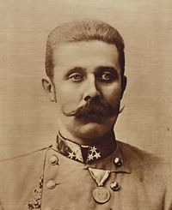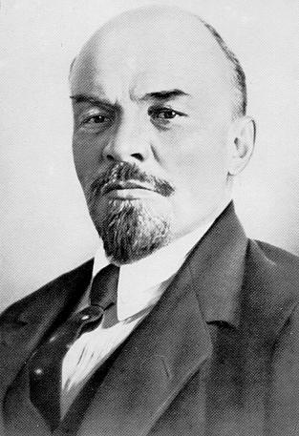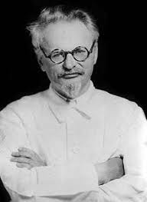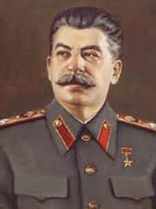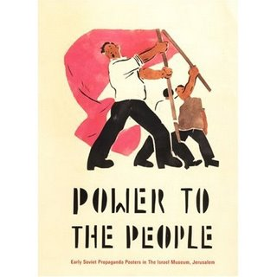
Czar Nicholas II Archduke Ferdinand Vladimir Lenin Leon Trotsky Joseph Stalin Russian Rev. Poster
World War I
In many ways Russia's disastrous participation in World War I was the final blow to Czarist rule. In the very first engagement with the Germans (who had sided with the Austro-Hungarian Empire) during the Battle of Tannenberg, the Russian army was beaten and suffered 120,000 casualties to Germany's 20,000. A continuing series of losses and setbacks meant that Nicholas left St. Petersburg in the autumn of 1915 to take personal control of the army. By this time Russia was sending untrained troops to the front, with little or no equipment and fighting in an almost continual retreat. In 1916, morale reached an all time low as the pressure of waging the war fell hardest on lower class families whose sons were being slaughtered at the front and who suffered severe food and fuel shortages at home. The Czar and the Imperial regime took the blame as civil unrest heated up to boiling point.
The February Revolution (1917)
On February 23rd, 1917, the International Women's Day Festival in St. Petersburg turned into a city-wide demonstration as exasperated women workers left factories to protest against food shortages. Men soon joined them. On the following day - encouraged by political and social activists - the crowds multiplied and virtually every industry, shop and business had ceased to function as almost the entire populace went on strike.
Nicholas ordered the police and military to intervene, but the military was no longer loyal to the Czar and many joined the people in demonstrations. Fights broke out and the whole city was in chaos. By February 28th , over 150,000 troops mutinied from the army and looting and rioting was widespread.
Faced with this impossible situation, Czar Nicholas abdicated his throne, and gave power to his brother Michael. Michael refused to accept leadership unless he was elected by parliament. He resigned the following day leaving Russia without a head of state.
The Provisional Government
After the abdication of the Czar and his brother (Romanov family) a Provisional Government was quickly formed by leading members of the parliament and recognized internationally as Russia's legal government. It was to rule Russia until elections could be held. However its power was by no means absolute or stable. The Petrograd Soviet organization was a union of workers and soldiers that held enormous influence. This group favored full-scale Socialism over more moderate democratic reforms suggested by members of the Provisional Government.
After centuries of Imperial rule, Russia was consumed with political fervor, but the many different factions, all touting different ideas, meant that political stability was still a long way off directly after the February Revolution.
Lenin Returns to Russia
One person looking to take advantage of the chaotic state of affairs in St. Petersburg was Vladimir Lenin. Lenin had spent most of the 20th Century travelling and and campaigning in Europe - partly out of fear for his own safety, as he was a known Socialist and enemy of the Tsarist regime. With the Tsar under arrest and Russian politics in chaos, Lenin saw the opportunity to lead his party (the Bolsheviks) to power. From his home in Switzerland he negotiated a return to Russia with the help of German authorities.
When Lenin returned in April 1917, he was greeted by the Russian people and many leading political figures with great applause. Rather than uniting the different parties, he immediately condemned the Provisional Government and the Petrograd Soviet organization. In his April Theses, published in the Bolshevik newspaper Pravda, he suggested an immediate end to World War I.
At first, people did not trust Lenin and the Bolsheviks, but with powerful slogans like 'Peace, Land and Bread,' Lenin begin to win the hearts of the Russian people -- especially those who were increasingly unable to stomach war and poverty.
Summer of 1917
During the summer of 1917, Lenin made several attempts to encourage another revolution like the one in February, with the aim of overthrowing the Provisional Government. When the Machine Gun Regiment refused to leave Petrograd (as St. Petersburg was then known) for the frontlines, Lenin sought to control them instead. Kerensky, arguably the most important figure of the time - a member of both the Provisional Government and Petrograd Soviet - thwarted the coup. Experienced troops arrived in the city to silence any disturbances and the Bolsheviks were accused of partnering with the Germans. Many were arrested and Lenin escaped to Finland.
Despite this disaster, Lenin continued plotting and scheming. Meanwhile Kerensky suffered his own political setbacks and even had to appeal to the Bolsheviks for military aid when he feared his Minister of War, Kornilov, was aiming for a military dictatorship. By autumn, the Bolsheviks were winning majority votes within the Petrograd and Moscow Soviets. Leon Trotsky was elected as president of Petrograd.
The October Revolution
By the Julian Calendar in 1917, used in Russia at the time, the revolution took place on October 25th. This would be November 7th according to the Gregorian Calendar used today. It is therefore often referred to as the November Revolution.

*****The Gregorian calendar is also known as the Western Calendar. It is the internationally accepted world calendar. It was introduced by Pope Gregory XIII and named after him. The motivation for reforming the Julian calendar was that the Julian calendar estimated the time between vernal equinoxes is 365.2 days when in fact it is about 11 minutes less. The error between this time is 10 days accumulated at the rate of three days every four centuries. Since the equinox s connected to the celebration of Easter, the Roman Catholic Church decided to amend the calendar.

With Russian politics still in a state of constant change, Lenin realized that October was the time to capitalize on Bolshevik popularity. He planned a coup that would overthrow the increasingly ineffective Provisional Government and replace them with the Bolsheviks. On October 10th, he held a famous meeting with twelve party leaders and tried to persuade them that a revolution was required. Despite receiving the backing of only 10 members, plotting went ahead.
October 24th was the date selected. On that day, troops loyal to the Bolsheviks took up crucial positions in the city, such as the main telephone and telegraph offices, banks, railroad stations, post offices, and major bridges. Guards hired by the Provisional Government, who got wind of the plot, fled or surrendered without a fight. By the 25th of October, every key building in St. Petersburg was under Bolshevik control, except the Winter Palace where Kerensky and the other Ministers were holed up with a small guard.
At 9 pm that day, Kerensky fled the Palace by car -- never to return to Russia. On the 26th the Palace was taken with barely a shot fired, and Lenin's October Revolution had been achieved with a bare minimum of drama or bloodshed.
Aftermath and Consequences
Despite being allowed to seize power so easily, Lenin soon discovered that his support was far from absolute. His Peace Policy with the Germans was particularly unpopular as it gave away large amounts of Russian territory. Shortly after the October Revolution, the Russian Civil War broke out between the 'Reds' (Communists) and the 'Whites' (Nationalists, Conservatives, Imperialists and other anti-Bolshevik groups). After a bloody four year struggle, Lenin and the Reds won, establishing the Soviet Union in 1922, at an estimated cost of 15 million lives and billions of rubles. In 1923, Lenin died and Stalin took over the Communist Party, which continued to rule Russia until 1991 when the USSR was dissolved.

1917 Russia Questions
- Who took power after Czar Nicholas II?
- When did the two major revolutions of 1917 take place?
- What was the result of the two revolutions?
- What problems made the Russian people desire to overthrow Nicholas II (5 reasons)?
- What did Czar Nicholas II create in his October Manifesto? How did he undermine this creation?
- What happened to the Russian army in the Battle of Tannenberg?
- What happened on International Women’s Day in 1917? How did the military lead to the overthrow of the Czar?
- Why did Nicholas’ brother Michael refuse to take the crown when Nicholas was overthrown?
- What type of political system did the “temporary government” prefer?
- Who was the leader of the Bolsheviks? Why was he in Europe?
- What slogan did Lenin use to gain popularity with the people?
- Why did Lenin want to encourage the Russian people to overthrow the temporary government?
- What is the difference between the Julian calendar and the Gregorian calendar?
- How did the Bolsheviks take power on October 24th, 1917?
- Describe the Battle of the “Reds” and the “Whites”.
- What was established in 1922? What was the cost in dollars and loss of life?
- After the death of Vladimir Lenin, who took power?
- When did the Communist Party lose power in Russia?

